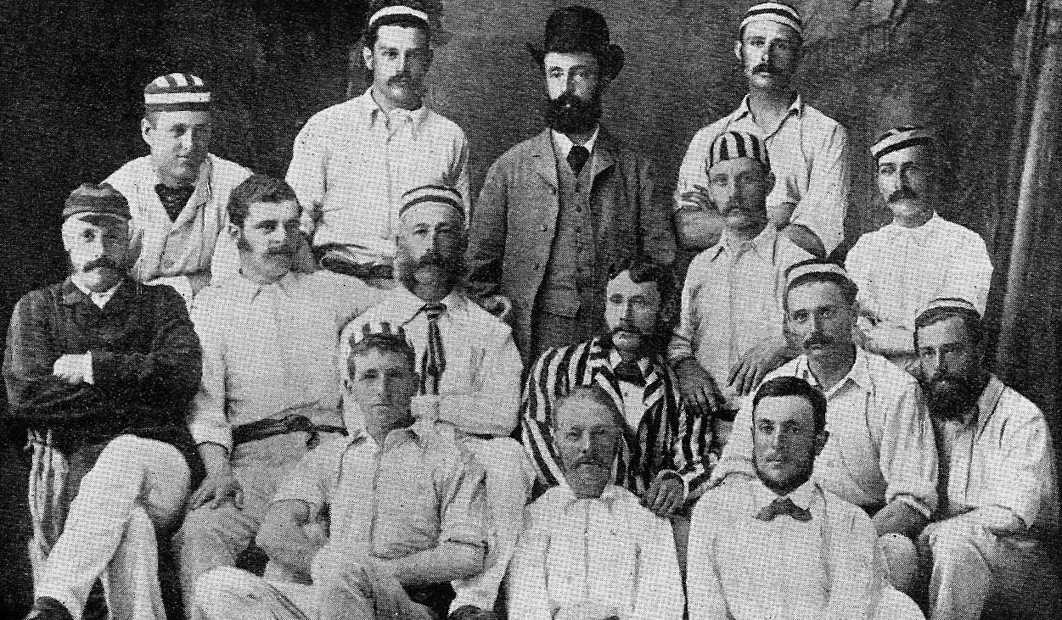

**Canterbury touring team 28 December 1883 to 7 January 1884.**

**Back row:** AT Chapman, WV Milton, TD Condell, F Wilding (captain)

**Middle row:** WJ Pocock, HH Secretan, ECJ Stevens, JT Buchanan, H Edser, A Longden, FBW Malet, H Cotterill

**Front row:** TD Harman, D Ashby, WH Dudney